Database Project-Movie Recommender

MST JAHAN

Mst jahan

2021

For my project, I create a movie recommender that generated random suggestions on a topic. I decided on this topic because I wanted to help movie watchers decide on what movie they should watch. Watching movies is a very popular activity for the majority. When it comes to choosing what to watch, most people end up getting stuck and can't make a decision. With the spread of Netflix and other streaming websites, movies have become readily available with a wide range of choices. It can sometimes take an average person seven to ten minutes just deciding on what to watch.

I wanted to create an app that can help solve this common problem. I decided to make this project an easy-to-use mobile application so that anyone can be able to use it at any given time. The app does not require any user login or signup. It is simple and easy to use, all the user needs to do is just download the app, open it up, and click the button, which will then generate a random movie for them to watch.

When it came to implementing the project, I first need to set up my tables, which hold all the information about the movies. I had created about ten tables with ten columns in each with different topics related to the movies. I created the main table which was my movie table, this held the information for movie title and year. I then created a rating table, which held the information on all the ratings that the movies received by the bored of MPAA, the rating range from PG to R rated. I then need to create a genre table to associate with each movie in the list. I also wanted to include the main director's names associated with the movies so I created another table for that. I did this just in case some users enjoy watching movies created by certain directors. I then created a review table. I wanted to add this extra feature just to give the user some more information on what other critics might have thought about the movie just in case if they decided not to go with the first topic. Once I had all my tables completed, I need to map them to each other using foreign keys. I mapped all the tables to my main movie table which I later used to generate all the topics from each column.

After I created all of my tables I then need to figure out how I was going to make the connection from PHP my Admin to an interface. Since I wanted to make this a mobile app, I decided to use Android Studios. I never created a project similar to this one before, so I did not have much knowledge on how to do proper connections. I decided to use the Java database connectivity API. This allowed for managing the connection between the databases and making the query commands a lot easier. I just need to download the file for it and insert it into my folder and make a call to the URL associated with the My PHP account so that I can retrieve the data into my interface.

Once the data was retrievable, I was then able to continue writing the main code which allowed for the list to be outputted. I need to first figure out how to generate the movies in random order. To do this I just created a simple order by rand query that outputted the list in random orders. I then need to figure out how to retrieve the rest of the data from the other tables into the movie tables. To do this I just used the inner join command to join the columns with their associated keys. This allowed for all the information to be outputted for the user to see.

The features in the app include a text view and a button The text view is where all the information is held and the button allows for the user to click for the information to be retrieved. I initially wanted for the button to be clickable multiple times, but I was not able to implement this properly and it only allows for one-click at a time. In the future, as I continue working on this project, I will try to figure out how to implement this into my application. I believe that companies such as Netflix and Hulu can also use this application to help their customers decide on what they can watch from their websites.

In conclusion, this app was created as an easy-to-use application that can help people solve a dilemma on what to watch. In the future, I will continue working on this app to improve and enhance its features.

APP:

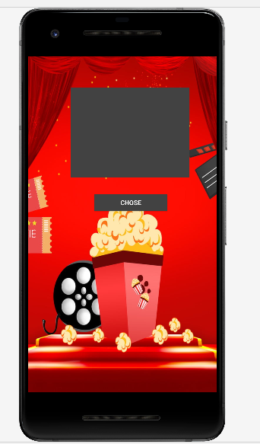 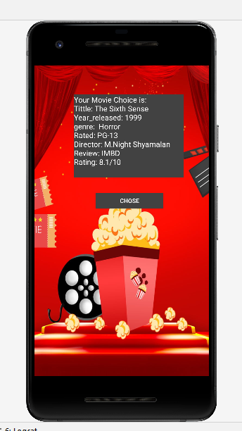

Relational Diagram:

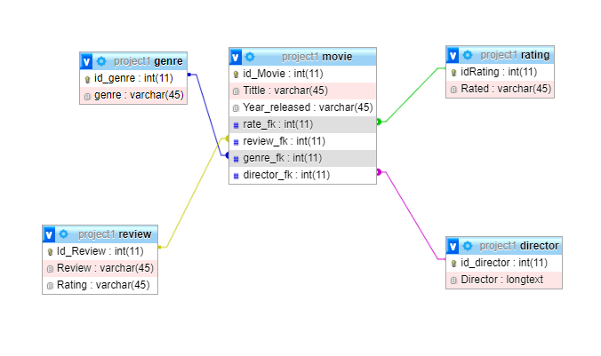

USE CASE For Connection

Data-Base

Interface



ER DIAGRAM

Movie info opens up for view

Info send back to user

APP OPENS

Generate random strings

Interface generates info from database

User click chose button

APP LOADS

OPEN APP

USER

REFRENCE:

<https://deadline.com/2019/07/streaming-overload-netflix-nielsen-report-average-viewer-takes-7-minutes-to-pick-what-to-watch-1202640213/>

<https://www.javatpoint.com/example-to-connect-to-the-mysql-database>

https://blog.dataiku.com/2012/09/10/a-simple-recommendation-engine-implemented-in-different-languages